Creating Self-Portraits

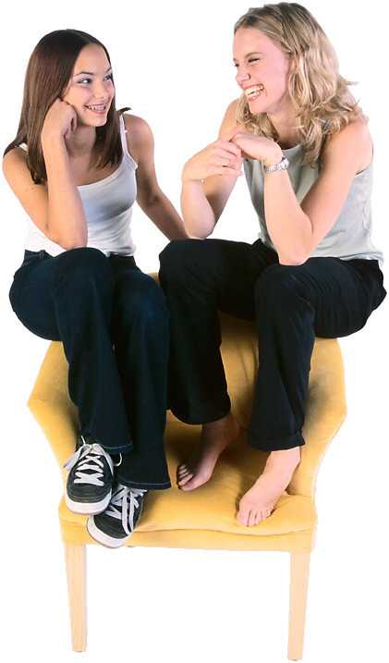
Creating Self-Portraits is a method for helping youth recognize how they are changing and growing. It helps them figure out: Who are they now? What skills do they have? What do they know? In what direction are they headed? What's important to them? With a clear picture of where they started, youth can track their development.
Creating Self-Portraits provides a method for identifying and organizing components of clients' work, hobbies, and life without suggesting job names.
Self-Portrait components:
- meaningfulness (values, interests, beliefs, and barriers) issues
- outcomes or goals for work and life
- activities that the individual has engaged in or wants to engage in
- tools and techniques that the individual has or needs in order to carry out desired activities
Characteristics of the Self-Portrait
- The Self-Portrait can be used for making decisions, whether work-related or not.
- The Self-Portrait evolves over time, allowing students to add, subtract, and reorganize information to best capture their changing selves.
- The Self-Portrait moves students away from preoccupations with job titles and towards focusing on what they actually want to do in work and life.

This opens the door to career paths

The Self-Portraiting Steps

What Is Meaningfulness?
Values are those things that are fundamentally important to the person; they form the bedrock of individual actions. Some examples of values include:
- people
- creativity
- growth and development
- family
- health
- spirituality
- work
Values cannot be right or wrong; they simply exist. They are unique to each person and reflect what's most important to the particular individual.
Beliefs are ideas or world-views that guide a person's actions. Some sample beliefs include:
- belief in God
- belief that people are inherently good
- belief that money brings happiness
Interests are things that the person enjoys or simply gets a kick out of.
Some examples:
- interacting with people
- using your hands
- solving problems
- playing with kids
- organizing information
- being creative
- leading a team
Barriers to meaningfulness are things that get in the way of fulfilling values, beliefs, and interests. Some examples of barriers to meaningfulness include:
- lack of finances
- location
- lack of education
- needs of dependents

What Are Outcomes?
Outcomes are things an individual wants to achieve or accomplish in life. These are what the person wants to get from successful career planning. Outcomes can be classified in terms of three categories: personal, work-related, and educational. Some examples:
- children
- home ownership
- successful marriage
- travel experiences
Personal outcomes can be anything an individual wants to get out of life.
Work-related outcomes refer to anything that individuals want to achieve in their work. Some examples of work-related outcomes include:
- moderate income
- variety
- new developments in a field
- improved lives of people
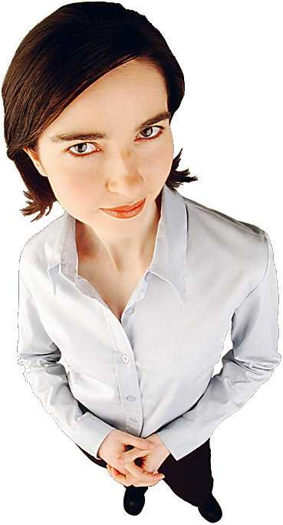
Work-related outcomes are often more individual-specific than personal outcomes. An outcome for an artist, for example, may be renowned pieces of art, whereas an outcome for an educator may be children who can adapt to a changing world.
Educational outcomes usually are tied to work-related outcomes. That is because they often exist for the sole purpose of ensuring that the work-related outcomes are achieved. For example, the educational outcome of studying photography may be desired only because of a specific work-related outcome, such as world-class photo-journalist.
- Values: What's so important about these outcomes you've mentioned? What's really important to you? What gets you out of bed in the morning and wanting to face a new day?
- Beliefs: What clichés do you live by? What sayings do you repeat to yourself?
- Interests: What's fun for you? What do you enjoy or get a kick out of?
- Personal Outcomes: What do you want to get out of life? What do you want to achieve?
- Work-Related Outcomes: What do you want to get out of work? What do you want to achieve?
- Educational Outcomes: What educational accomplishments would you like to make?

If you have difficulty verbally articulating ideas, move to a visual format. For example, from a stack of magazines create a collage of pictures that represent outcomes and/or meanings.

3. Determining Activities
What Are Activities?
Activities are tasks you want to undertake in the future, or need to undertake in order to achieve your outcomes. These are the roads to travel to arrive at your outcomes. Some examples of activities include the following:
- develop rapport with customers
- install brake shoes and pads
- assess clients
- frame walls
- play guitar
- clean coin acceptors
Activities combine skills, attitudes, and knowledge into useful sets of procedures. Activities are thus more than a simple listing of skills, attitudes, or knowledge; they provide purpose and direction to the persons skills, attitudes, and knowledge. It is important to identify activities because these show students (and potential employers) how they are able to reach specific outcomes; hence, they are a demonstration of ability and competence.

How Are Activities Determined?
Activities usually are identified after outcomes and meaningfulness issues have been determined, or, at any time during Self-Portraiting.
- Start with past activities, that is, activities you have previously engaged in.
- Move to identifying preferred activities— ones you want to undertake to reach desired outcomes.
- Move to needed activities—ones you must undertake in order to achieve desired outcomes. Needed activities may or may not be the same as preferred activities. Different methods of identifying activities can be used depending upon what types of activities are being sought.
Identifying Past Activities. Identify things done in the past, including hobbies, sports, leisure activities, work experiences, or volunteer experiences. For example, a young person with no previous work experience may respond with the following:
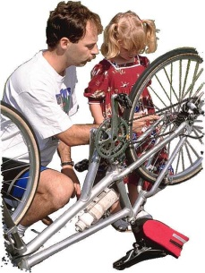
"Well, I don't know if this is helpful, but I used to really be into cycling and I've fixed a lot of bikes. Let me list some of things I can do with bicycles. I can repair tires, replace chains, install sprockets and derailleurs, replace bearings, and straighten wheels."
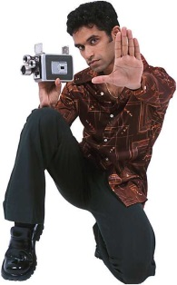
With students, it's important to identify as many activities in as many spheres of life as possible. Later, this will help show your transferable skills—activities that you’ve completed in other parts of your life— that can apply to your work life. With individuals who have had a significant amount of work experience, focus more on previous work-related activities. In all cases, however, it is always safest to identify as many activities as possible.
Identifying Preferred Activities. After identifying as many past activities as you can remember, begin identifying preferred activities. This gets at how the you want to achieve desired outcomes.

"In the best of all worlds, what would you like to be doing on a day-by-day basis? How would you ideally like to reach your goals?"
You might be thinking something like this:
"I'm not sure I know enough about the video or film industry to know what I'd like to be doing. I guess I'm really interested in the special effects used in shows. Like, you know, I'd love to design miniature sets with robotic characters like monsters and space aliens Or building sets where whole cities are on fire, and it's all done in miniature."
These then are the preferred activities that are being identified:
- create special effects (miniaturized)
- design miniature sets
- design robotic characters
Now you are becoming much more specific about a desirable role.
If you can create a comprehensive list of preferred activities, the next step is to sequence these activities in order of preference. For example, the you may prefer to working with robots more than with miniature sets. Identify this in the Self-Portrait by listing preferred activities in the appropriate sequence.
Identifying Needed Activities. Move to identifying needed activities after identifying all preferred activities. The list of needed activities will specify what to do to continue the process of managing your career development. Common examples of needed activities include:
- develop network
- job shadow
- conduct library research
- interview experts
By engaging in these activities, you will be better able to continue identifying preferred activities, clarifying outcomes, and more precisely, specifying values and interests.

4. Choosing Tools and Techniques
Having identified the your outcomes, meaningfulness issues, and activities, the Self-Portraiting process moves to the identification of tools and techniques.

What Are Tools and Techniques?
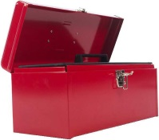
Tools and techniques are skills, knowledge, and attitudes that enable you to effectively carry out activities. Where activities are usually goal-directed and specific, tools and techniques can often be applicable to a range of different activities in order to achieve a variety of goals. In other words, tools and techniques are generally far more transferable than activities.

How are Tools and Techniques Determined?
In many ways, identifying tools and techniques is the simplest part of the Self-Portrait to complete. Although it's not difficult, the Tools and Techniques column of the Self-Portrait often is the longest column and can take some time to complete.
To identify tools and techniques, select one of your past activities and ask:
- What sorts of skills did you need to undertake this activity?
- What kinds of knowledge did you need to undertake this activity?
- What attitudes did you need to undertake this activity?
Repeat this process for every past activity listed on the Self-Portrait. For example:
"To repair a bicycle tire, I guess I needed some basic skills like using combination wrenches and using screwdrivers, and I suppose I used some techniques for removing and replacing tires. On the knowledge side, I had to simply know about different types of tires, tubes, and wheels. As for attitudes, all I can think of is that you really have to be careful or thorough to repair tires well."
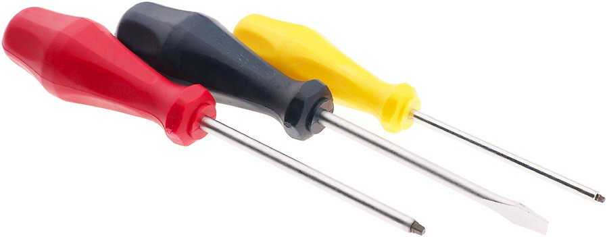
Pulling out the tools and techniques from this narrative, you could write the following list:
- use combination wrenches
- use screwdrivers
- use tire removal and reinstallation techniques
- understand bicycle tire, tube, and wheel types
- exercise care, thoroughness
Following this procedure for each past activity, you will generate a long list of tools and techniques.
After all the past activities have been explored for underlying tools and techniques, move along to preferred and needed activities for the following:
- Tools and techniques from past activities that are transferable to preferred and needed activities—What skills, knowledge and attitudes could help to achieve the preferred or needed activities?
- Tools and techniques that will be needed in order to carry out preferred and needed activities—What additional skills, knowledge and attitudes
In the first case, each tool and technique that is transferable to preferred and needed activities can simply be highlighted with an asterisk or by underlining.
Notice the esteem-building power of identifying tools and techniques in this way. In a very short period of time, you identify a whole host of abilities. Almost invariably, completing this portion of the Self-Portrait increases confidence. For example, consider a robber whose only successful activity has been break and enter. To break and enter successfully, he needs the following tools and techniques:
- organizational skills
- planning skills
- rapport building skills (to garner the support of a confederate)
- observation skills
- trust-testing skills (to ensure the confederate is trustworthy)
- alarm system knowledge
Even though breaking and entering is not a socially acceptable activity, it requires a variety of tools and techniques that can be transferred to many activities that are socially acceptable.

